**PRACTICAL-1**

OBJECTIVE - TO CREATE EC2 INSTANCE

**Steps to Create an EC2 Instance**

1. **Login to AWS**
   * Go to AWS Management Console.
   * Sign in with your credentials.
2. **Navigate to EC2**
   * In the search bar, type **EC2** and select it.
3. **Launch Instance**
   * Click **Instances → Launch Instance**.
   * Give your instance a **name**.

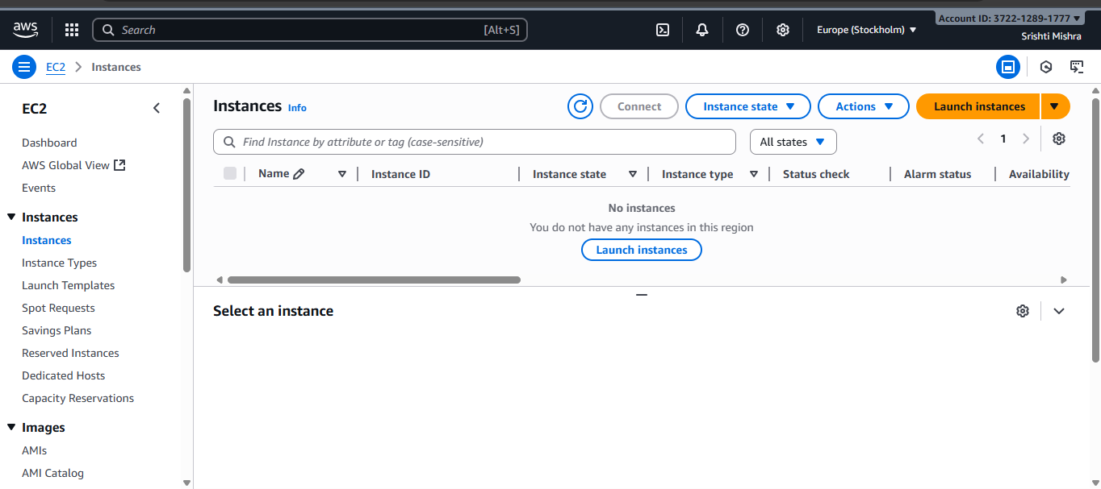

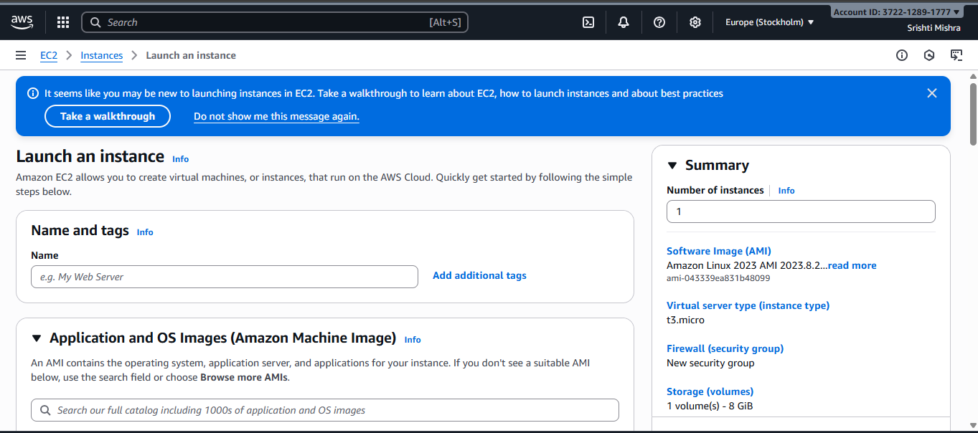

1. **Choose Amazon Machine Image (AMI)**
   * Select an OS image (e.g., Amazon Linux 2, Ubuntu, Windows).
   * For beginners, choose **Amazon Linux 2 (Free tier eligible)**.
2. **Choose Instance Type**
   * Select **t2.micro** (free tier eligible).
3. **Configure Key Pair**
   * Create a new key pair (RSA) and download the **.pem file**.
   * This will be used later to connect to your instance.

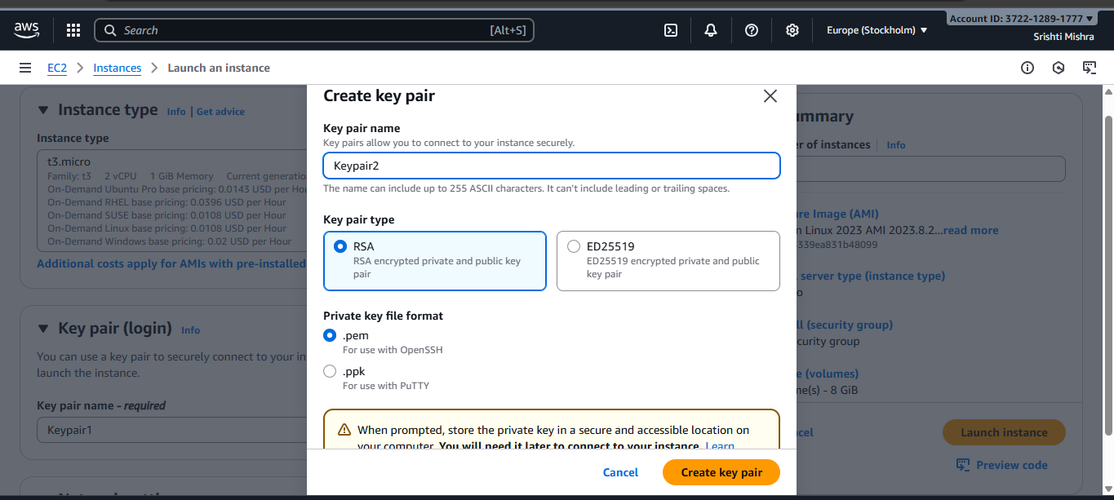

1. **Configure Network & Security**
   * Leave default **VPC and subnet** (unless you want custom networking).
   * Under **Security group**, allow:
     + **SSH (port 22)** for Linux
     + **RDP (port 3389)** for Windows
     + **HTTP/HTTPS** if you’re hosting a website.
2. **Configure Storage**
   * Default 8 GB is fine (increase if needed).
3. **Launch Instance**
   * Click **Launch Instance**.
   * AWS will start your instance.

